Chapter 5 activities

Report 1

1. The purpose of this lab was to demonstrate how to install Windows Search Service
2. The lab had me install a new feature in server manager. The lab also had me enable the process to start at boot, and I manually started it after installation had completed.
3. I used server manager to complete these tasks
4. 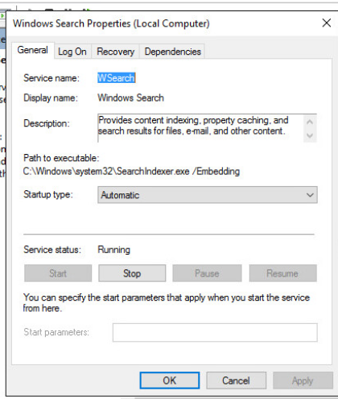

Report 2